Stack Exchange

🎓 Definition
# Source: ScreenShots Source: Provided by: [Persons Table -> ID Column: 1, Name_En Column: Motasem Essam] -> Tool: [Lightshot Program] -> From [Site: https://stackexchange.com/] on [11/13/2025]
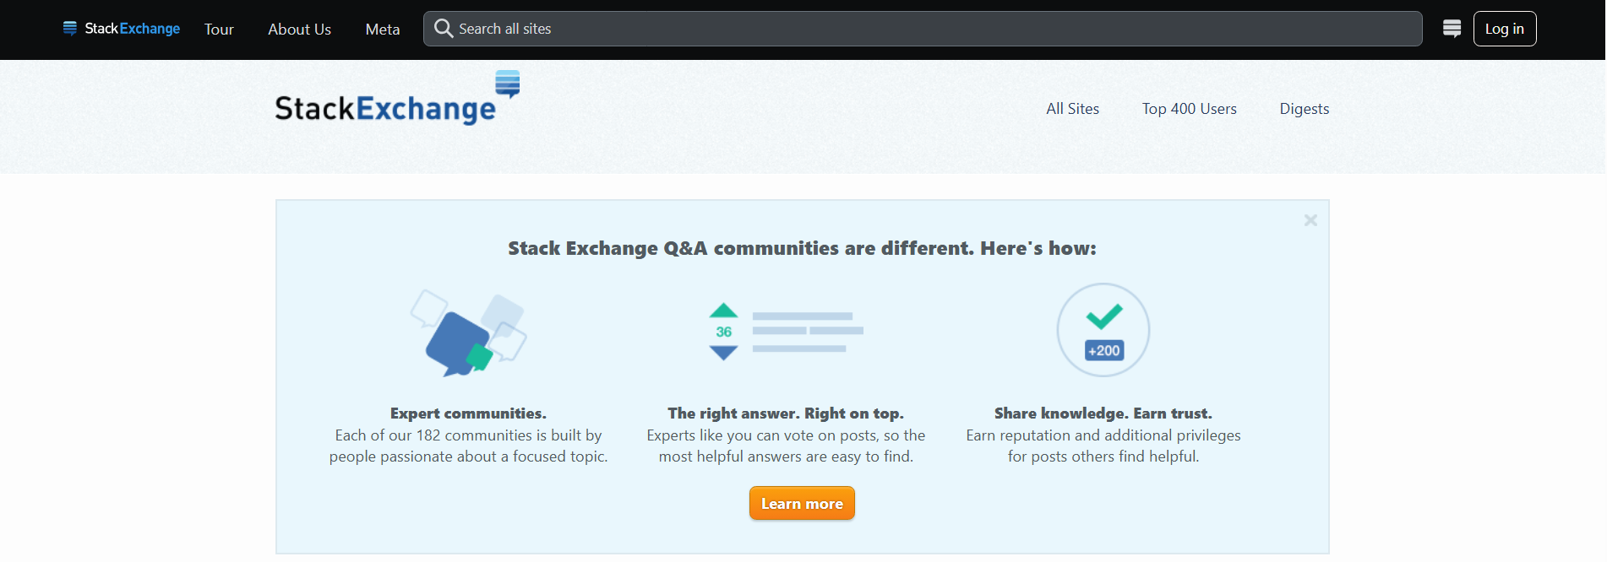
# Source: AI Source: Provided by: [Data Path: Persons Table -> ID Column: 1, Name_En Column: Motasem Essam] -> From: [ChatGPT] on [11/13/2025]
Stack Exchange — https://stackexchange.com/ — is a network of question-and-answer (Q&A) websites covering a wide range of topics. Here’s a detailed breakdown:

📌 Overview
# Source: AI Source: Provided by: [Data Path: Persons Table -> ID Column: 1, Name_En Column: Motasem Essam] -> From: [ChatGPT] on [11/13/2025]
- Stack Exchange is not a single site but a network of dozens of Q&A communities.
- Each site focuses on a specific topic, for example:
  - Stack Overflow – programming and software development
  - Super User – computer hardware/software for power users
  - Ask Ubuntu – Ubuntu/Linux questions
  - Math Stack Exchange – mathematics questions
  - Photography Stack Exchange – photography tips and techniques
- Users ask questions and other community members provide answers, which can be voted up or down to highlight quality content.

⚡ Key Features
# Source: AI Source: Provided by: [Data Path: Persons Table -> ID Column: 1, Name_En Column: Motasem Essam] -> From: [ChatGPT] on [11/13/2025]
- Reputation System: Users earn reputation points when their questions or answers are upvoted, which unlocks privileges like editing posts, voting, and moderating.
- Community Moderation: Experienced users and moderators help enforce rules, manage content, and ensure quality.
- Tagging & Search: Questions are organized with tags, making it easy to find related topics.
- Free Access: Anyone can read and search content; creating an account allows asking questions, answering, and voting.

✅ Purpose
# Source: AI Source: Provided by: [Data Path: Persons Table -> ID Column: 1, Name_En Column: Motasem Essam] -> From: [ChatGPT] on [11/13/2025]
- Stack Exchange aims to provide high-quality, peer-reviewed answers to questions on specific subjects.
- It emphasizes expertise, clarity, and accuracy rather than discussion or open forums.

🛡️ Safety & Legality
# Source: AI Source: Provided by: [Data Path: Persons Table -> ID Column: 1, Name_En Column: Motasem Essam] -> From: [ChatGPT] on [11/13/2025]
- Completely legal and widely used worldwide.
- Content is community-generated but moderated to avoid spam or malicious links.
- Safe to use for learning, research, and professional problem-solving.

📌 Summary
# Source: AI Source: Provided by: [Data Path: Persons Table -> ID Column: 1, Name_En Column: Motasem Essam] -> From: [ChatGPT] on [11/13/2025]
Stack Exchange is a professional and educational Q&A network. Unlike sites like GetIntoPC or The Pirate Bay, it does not distribute software or pirated content. Its value is in knowledge sharing, problem solving, and community-driven learning.

